Chapter 4, Problem 70.

Determine the maximum power delivered to the variable resistor R shown in the circuit of Fig. 4.136.

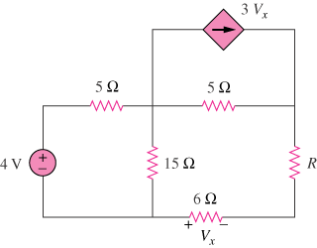

Figure 4.136
For Prob. 4.70.

